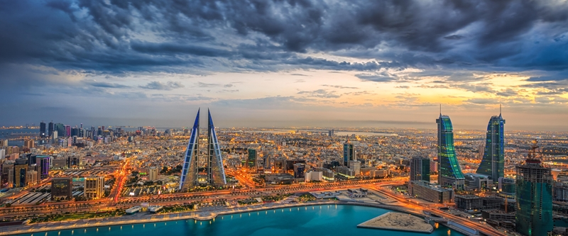Bahrain

Comprising of more than 30 islands, and one of the most visited countries in the Middle East, Bahrain is famous for its impressive mosques, burial mounds and traditional markets. It's a country that blends modern Arab culture with ancient historic destinations that reflect 5,000 years of Bahrain civilization. Bahrain is famous for its gorgeous pearls which used to make their way all over the world from its bustling ports. Contrary to popular belief, it was these precious jewels from the sea that first made this Middle Eastern hub rich, rather than its more famous oil. Bahrain is steeped in history and culture, not to mention a whole load of elegance. It’s kingdom combines modern Arab culture and historical places which reflects five thousand years of Bahrain civilization. It’s climate is mostly hot and dry in summer season with low level wind directed toward Bahrain through the Zagros Mountains across the Persian Gulf. There is no regularity for rainy season, mostly rainfall occur in winter season. Bird watching, scuba diving and horse riding are popular tourist activities in Best Tourist Places in Bahrain. Bahrain is distinguished by its privileged location as it does not share land borders with another country and is surrounded by the sea from all sides.

This unique location makes it popular and also boasts a variety of attractions that attract tourists from all the Gulf countries and the world. Planning a destination wedding in Bahrain is so mystifying due to this country's beauty and wedding venues that have no other match in the world.

* **Four Seasons Hotel Bahrain Bay**

A romantic island setting for Bahrain wedding celebrations, Four Seasons Hotel Bahrain Bay offers a sense of privacy, exclusivity and grandeur – welcoming from 30 to 550 guests. Chic modern design meets local tradition in their combination of two ballrooms, and an expansive outdoor terrace and oval-shaped lawn with Manama skyline views.

* **The Ritz Carlton Bahrain**

Treasure the most special day of your life with a romantic celebration that goes beyond your wildest dreams at The Ritz-Carlton, Bahrain. Set in the heart of paradise, this stunning resort offers the most magical setting of all, in which to begin the rest of your lives together.

* **Sofitel Bahrain Zallaq Thallasa Sea and Spa Hotel**

From a board meeting to a banquet for 1000 in Al Nakheel Ballroom they offer meeting rooms and facilities to suit every need. Their private palm-filled Sofi Island is a stunning location for photo shoots receptions and corporate events in Bahrain. They have hosted several royal weddings and a spectacular themed ball.

* **ART Rotana Amwaj Islands Hotel**

Plan your wedding in style and celebrate at one of the properties! Hold a huge traditional white wedding surrounded by family and friends, a simple elegant private ceremony, or that something a little bit different for an extra-memorable day, the choice is yours. It will be an absolute pleasure to host your wedding ceremony or celebration at ART Rotana Amwaj Islands Hotel.

* **Movenpick Hotel Bahrain**

The Mövenpick Hotel Bahrain is an award-winning five star property, located adjacent to Bahrain International Airport and with a magnificent view of the sprawling lagoon and resort. A dedicated Meet and events team offers an attentive service and reliability to ensure complete success of your event and an unforgettable experience.

* **Elite Hotel & Spa**

Elite Resort and Spa is the Best Family Resort & Luxury Spa Resort in Middle East located on Muharraq bay which is next to the Airport and 5 minutes drive from the City Centre. This Resort is the winner of Best Four Star Resort in Bahrain awarded by Bahrain Food and Travel Awards 2018. Country winner by World Luxury Hotel Awards.

Cruise

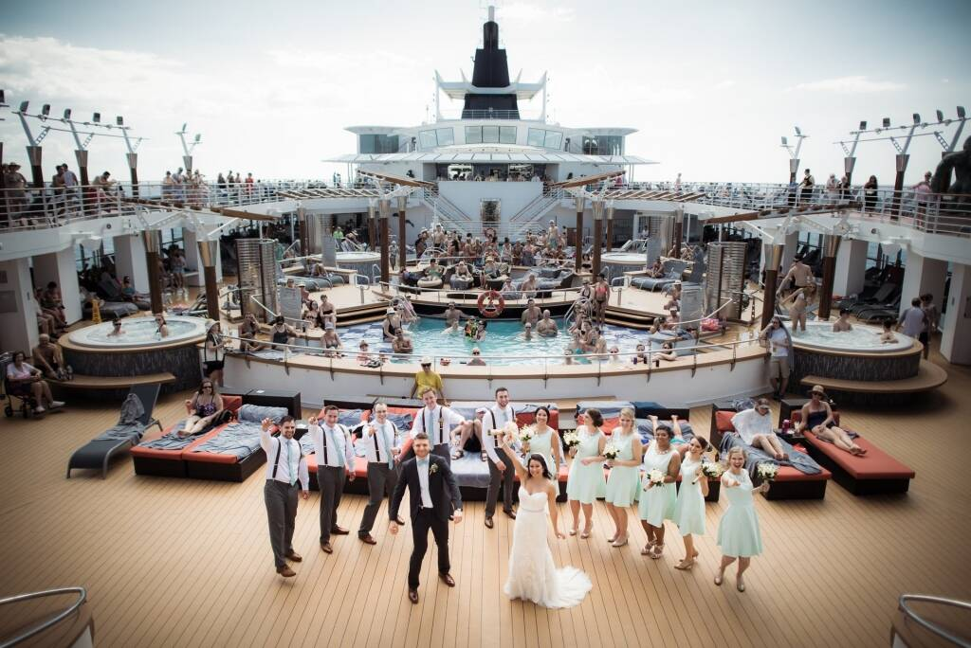

Taking your unforgettable weddings vows surrounded by family and water on the four sides sounds adventurous right. Cruise weddings have grown at a phenomenal rate in the last few years. Years ago, there were practically none, but this year there will be thousands. Cruising gives a majestic experience to the people in summers. A cruise is not only a small moving hotel but a tiny island in itself. People love sailing while spending quality time with your loved ones is worth experiencing. Many cruise lines offer a variety of services to help you plan a shipboard or shore side ceremony, followed by a romantic cruise honeymoon. Plus, a wedding on a cruise ship can be a great value. Weddings at sea can be the ultimate in romance. If you want to get married at sea by the captain, you're limited to only a handful of cruise lines, due to legal limitations that are based on ships' countries of registry. On the "can officiate" list are Celebrity Cruises and Azamara Club Cruises, whose ships are registered in Malta; Norwegian Cruise Line, through the Bahamas; and Princess Cruises and Cunard, with ships in Bermuda. Some of the world famous Cruise lines for your heavenly wedding are as follows:

* **Princess Cruises:**

Princess is a prime choice because, of all the lines offering shipboard wedding options, it provides one of the best combinations of features, services and facilities. Princess' "Tie the Knot" packages are available on all ships, and most ships have dedicated wedding chapels.

* **Celebrity Cruises**

Celebrity captains can perform both legal and symbolic ceremonies at sea (except on Xpedition). As of October 2017, they can also perform legal same-sex weddings at sea. The line's fleet of ships offers a pleasant mix of fun and luxury, leaving the happy couple and their guests with plenty to do before and after the big day. Celebrity also offers special supplementary "celebration packages" (for a fee) such as a welcome reception, tea service, cigar and whiskey party and trash-the-dress photo shoots to set the tone for a customized wedding cruise.

* **Disney Cruise Line:**

It's a fun and quirky choice, particularly for second-wedding folks who have young kids, and Disney offers a low-stress, low-hassle package. Disney Cruise Line's "Fairy Tale Weddings" are available on all four Disney Cruise Line ships.

* **Carnival Cruise Line**

Carnival appeals to younger couples with its fun amenities and spirited ships. Carnival Spirit, Carnival Pride, Carnival Legend and Carnival Miracle have onboard chapels, though you can buy Carnival's wedding packages on any of the ships in the fleet.

* **Norwegian Cruise Line**

Norwegian Cruise Line offers a vast array of options, which can turn basic packages into full-blown extravaganzas, and its ships feature a wide range of restaurants with easily available romantic dining for two. The cruise line also offers legal same-sex ceremonies, available in destinations where same-sex marriages are recognized by local law.

Italy

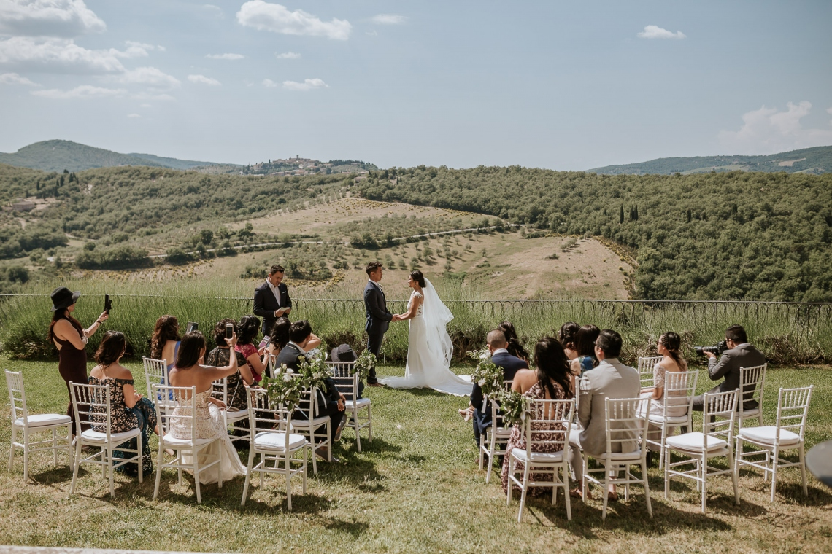

Italy is one of the most popular holiday destinations on earth, and it's no wonder. Ko One of the most famous Italian phrases 'la dolce vita' or the sweet life perfectly encapsulates the local lifestyle. Few parts of the world can claim so rich a history of art, architecture, music and food - or so intense a range of natural beauty.

Maybe it’s the sweeping romance of the Tuscan countryside, the haunting beauty of the Amalfi Coast, or the excitement of being surrounded by so much art, culture, and history, but there’s something about Italy that just warms your soul and puts a smile on your face again and again. It could, of course, be the divine food, which tastes like love and sunshine, or the courteous, well-dressed Italians, or the pleasure of doing nothing, but this country looks and feels so damn good, it’s impossible not to fall for its charms.

Rome celebrates its magnificent past with stunning museums and ruins of the world’s greatest empire; Venice enchants visitors with its meandering canals and fabulous marble palazzos; Florence is brimming with inestimable Renaissance art; and the Italian lakes ooze timeless sophistication with their postcard-perfect landscapes, pastel-colored waterfront towns, and sumptuous villas surrounded by immaculately groomed gardens.

Weddings indeed deserve an extra touch of magic. As far as, taking your vows with your better half goes- there are no better destinations in the world than the wedding venues in Italy. Over the past century, countless celebrities and famous people have recited their vows at either large or small wedding venues in Italy. So far, none of the couples has been disappointed, which in turn has raised the name of Italy for destination weddings to the topmost tier in the world. Here are some of the famous destinations for your joyful wedding.

* **Villa Monsogolio, Tuscany**

Located in one of the most splendid and picturesque parts of Italy, the vibrant countryside of Tuscany and the artistic Villa Monsoglio provide one of the perfect outdoor wedding venues in Italy. What gives the villa a unique edge are the array of fresco paintings, neatly trimmed gardens, and a wide reception area.

* **Vernazza, Italian Riviera**

With the gorgeous backdrop of a UNESCO World Heritage Site, Vernazza is one of the 5 incredible villages that comprise of Cinque Terre. The village is often regarded as by tourists as the most picturesque out of all the 5 villages. Depending on their preference, couples can choose between the seaside church, Old Monastery Town Hall, or any of the cafes located inside the fort for a memorable marriage ceremony.

* **Borgo Finocchieto, Tuscany**

Borgo Finocchieto is a huge medieval villa built in the Italian village of Borgo. This wedding venue in Italy became famous recently in Indian as two of the most famous personalities in India, Virat Kohli and Anushka Sharma, tied the knot at this beautiful wedding destination.

* **Lake Orta**

Italy is home to many pristine lakes and as a result, a few of them have become scenic wedding venues in Italy thanks to their charm, allure, and natural aura. After all, who wouldn’t be ensnared in a web of charm and flattery that comes in the backdrop of an alpine lake that is surrounded by a subtle mixture of Roman and Baroque architecture.

* **Civita Di Bagnoregio, Umbria**

Umbria is one of the lesser-heard tourist's destinations, equally as beautiful as Tuscany, that sits up as a brilliant place to immortalize your love story. A picturesque town surrounded by hills, Umbria is situated in central Italy in close proximity to Tuscany. It is often regarded as one of the unique wedding venues in Italy because of the lack of tourist attention that serves as a blessing in disguise for its visitors.

DUBAI

Just imagine getting hitched inside the goldy deserts accompanied by elite camels, standing beneath the tallest tower, wearing classy attire and getting married to your love in a marvelous city.

A luxurious place with an exotic destinations and royal ambience is considered to be a perfect place for a luxurious destination wedding. World’s largest mall, tallest tower, biggest dancing fountain, fashionable trends etc attracts all eyes making it exceptionally fashionable and a dream of every couple to plan a fairytale destination wedding at the foothills of the city.

It also offers a unique collection of atmosphere, venues, traditional attires, delicious recipes and what not. The azure sea, cool breeze, windy golden desert, dancing fountains and erectly standing towers adds a perfect background in your wedding making it exceptionally beautiful and helping you to perfectly knit the lovely moments together.

Some of the best venues to plan a wedding in Dubai are-

* **ATLANTIS THE PALM**

Being one of the most famous tourist destination, it is a perfect venue for nature lovers to enjoy their special moment of togetherness at this huge manmade island. The lush green valley glittered with wild blossoming flowers and an Arabic theme in the summer makes it all.

* **DUBAI OPERA**
* One of the most dazzling theatres with a grandeur doom has a unique style to convert into a banquet. The view it offers highlights the beauty of the event making your wedding a grand success. Its ability to transform from a theatre to a concert hall and then to become an amazing banquet or event hall.
* **EMIRATES PALACE**

It is one of the hottest and the most loved destination. The exceptional beauty, majestic surroundings adorned with elite architectural style forces one to plan a wedding here. A perfect wedding theme in a lovely atmosphere makes you cherish your auspicious day throughout your life.

THAILAND

Known for its Thai beaches, is a spectacular place for a Indian wedding adorned with beautiful sacred ritual. From lavish resorts near sandy beaches to the luxurious hotels and a perfect atmosphere it a perfect wedding gateway. It is a perfect venue for beach lovers who are looking to have a destination wedding near a sea coast. The best part is that it can turn into your budget. The décor and flowers are quite cheap and amazing.

Some of the well-known sites and venues to have a destination wedding at Dubai are-

* **KRABI**-

An amazing scenic beauty with stunning islands making it a perfect setting for a destination wedding at Thailand. The white sands surrounded by a beautiful blue happy beaches stands to be a perfect stage to exchange vows and gather the blessings from the atmosphere.

* **PHUKET**

The gorgeous weather, marvelous topography makes it a perfect place to celebrate your special day. Awestruck beaches, luxury hotels, underwater beauty glorifies your surroundings adding a perfect backdrop and mesmerizing your ceremony by making it special.

* **KOH SAMUI**

It stands to be a perfect place for Island wedding in the middle of sea cost surrounded by prestine beaches. It is a perfect destination for those who love destination beach wedding as it sets a perfect backdrop for true love birds.

* **THE KOH PHI PHI BEACH RESORT**

The wedding garlands, dusty golden sand, bright flowers and amazing view makes this beach a best venue for a destination wedding. Added to this, the fun-loving night life, the merry singing of oceanic waves makes it a heavenly abode thus adding a glorious sparkle on your day.

GREECE

Just imagine getting married in a unique Greek culture with the mighty blessings of Greek gods and following Greek mythology. Well known as being the birth place, the true souls getting etched there can be blessed for their birth of love in life. Famous for it’s ancient architectural designs, it can add beauty to your memories. Thus, Greece stands to be a perfect place for a wedding of the couple who love Greek tradition, or are nature lovers. The rich historic culture and a marvelous beauty makes it a perfect destination place.

Some of the best venues to attend a wedding in Greece are-

* **KALYMNOS**-

Want to enjoy every bit of your special day? Get your wedding planned here. The exotic location thrilled with excitement and joy makes your day grand and very special. Along with organizing a wedding, it also provides many amusement options making it a lovely venue. The goldy sands, royal blue water, exciting adventure makes it a famous water sport as well.

* **RHODES**-

An open gateway to attract the historical archaeologists and other history lovers is a famous island nation with a great choice for destination weddings. It’s historical glory makes it worldwide famous thus creating a perfect ambience for the true souls to tie knots and get etched.

* **KASTELLORIZO**-

Considered as the ancient Greek island, is well known for its dazzling beauty and hidden treasures. It is a silent island still hoping to get deciphered. It contains small mansions, a cathedral and considered a safe harbor to travel across.

* **SANTORINI**-

Covered with traditional caves, pebble stones lies a beautiful vistas adorned with a pleasant flute playing to provide a pure lovely rhythm to energize your vows and enhance them. The sea side view attracts your attention and gives you a time to spent together near the sea coast. You can also be accompanied by horse riding activity that can add an unforgettable memory to your special day.

SRILANKA:

Get wild with Sri Lanka!

Spinner dolphins leaping about in Kalpitiya and blue whales diving here and there during its season will bring you an adventurous journey. Sri Lanka also has 5,800 wild elephants ambling about and the biggest concentration of leopards in the world. You can see them in Yala national park, along with sloth bears and buffalo. You will get lost in the silence of beautiful caves. The Dambulla Buddha caves are filled with Buddha statues, cave paintings and are amazingly atmospheric. The caves have the power of filling you with peace. The Dambulla Buddha caves are the epic spot of Sri Lanka. The elephant sanctuary was famous there which will put you a positive mind towards wild life enjoyment. They play with you as like you have been with them daily. A newly reopened train route from Colombo to Jaffna promises an eye-opening journey through Sri Lanka. Even when you are moving to Sri Lanka, the way you go by will make you earn memories. Everywhere you go, the journey will teach you something!

The dish that you are having there will be surely a new one to your eye and first class of taste. You can dine on hoppers for a song. The dish is composed of a thin, crepe-like batter that's infused with coconut milk and spices and crisped into a bowl shape to hold fried eggs. It's versatile enough to serve as a breakfast dish, quick snack or hangover cure dependent on your needs. Sri Lanka is famous for its Ceylon tea. Walk past lush green tea plantations on a four-hour trek up to Ella Rock for amazing views. The Estates around there with ancient royalty will provide a pleasant walk. A Ceylon tea in an evening time with your loved ones in a royal estate is a best feel that everyone should crave for! Plenty of new hotels have opened in recent years, including a handful of beach resorts, including contemporary KK Beach, with its own beach club near Habaraduwa. How old are you doesn’t matter when it comes to a play in beach! A coffee in a beach with your love is bliss. Imagine a destination wedding there! A dream for many it might be. We can fulfil it for you. The eco-lodge at Kumbuk River is an epic piece of Sri Lanka. In the south east of the island, Arugam Bay is a crescent of golden sand that offers barrelling breaks during summer days and beach parties galore on balmy nights. In winter, have your time in Weligama. Such a fun filled place it is! It’s a much easier place to be gone. Because the transactions are quiet easier and simple to handle. Even the travel cost is worthy and cheap when compared to a foreign tour. In simple, it’s a best place for people who love to have destination wedding but low in their budget.

DUBAI:

A Dreamy Place of many! Dubai has more than 25 attractive epic places. Whatever paragraphs have been written will never be equal to its reality. It’s exactly a place created to steal our heart!

Dubai's landmark building is the Burj Khalifa, which at 829.8 meters is the tallest building in the world and the most famous of the city's points of interest. Night-time visits are particularly popular with photographers due to Dubai's famous city-lights panoramas. Back on the ground, wrapping around the Burj Khalifa, are the building's beautifully designed gardens, with winding walkways. There are plenty of water features including the Dubai Fountain, the world's tallest performing fountain. The Doha Road, just off Sheikh Zayed Road is a masterpiece gateway to adventure. Dubai Mall is the city's premier mall and provides entry to the Burj Khalifa, as well as the Dubai Aquarium. There is also an ice-skating rink, gaming zone, and cinema complex if you're looking for more entertainment options. The shopping and eating is endless, and there are nearly always special events such as live music and fashion shows within the mall. The surrounding that you will face there is entirely different from the surrounding that you face in India. Dubai is always Dubai! Dubai's excellent museum is housed in the Al-Fahidi Fort, built in 1787 to defend Dubai Creek. Not everyone loves to visit museum but everyone who visit this will start loving it!the old Dubai which is now called as Bastakia is an admireable place to vistit. Dubai Creek separates the city into two towns, with Deira to the north and Bur Dubai to the south. The creek has been an influential element in the city's growth, first attracting settlers here to fish and pearl dive. It has more innovative buildings in it. Jumeirah Mosque is considered by many to be the most beautiful of Dubai's mosques. The Future Dubai Gallery and the Dubai Frame will be an eye-catching place. The main difference between Dubai and India is the roads we pass by. The roads are worth of the taxes that they pay. A simple click on your DSLR on the roads of Dubai will give you a great image with memories. That is how descent it looks like! Particularly, Sheikh Zayed Road is the main thoroughfare running through Dubai's modern downtown business district. This wide, eight-lane highway is rimmed with towering glass, chrome, and steel high-rises along its entire length. Such beautiful hotels, beach sides, parks will admire you to more for a destination wedding.

ABU DHABI:

A modern city to travel into!

Capital of the United Arab Emirates, Abu Dhabi is a well-ordered, industrious city with a pretty waterside location. The Sheikh Zayed Grand Mosque is the major tourist attraction and wows all who visit. But the city also makes a good base for excursions to the desert landscapes of Liwa Oasis and the oasis city of Al Ain. Have you ever seen a spectacular museum like the Lovure Abu Dhabi? It can never be happen! Lovure Abu Dhabi traces the entire history of humanity's artistic achievements, from the Neolithic right up to the current day. To see a different side of Abu Dhabi's steel and glass exterior, head into the mangrove forests that still ring the islands along the shore surrounding the city. Another interesting thing to do for a really special experience is to sign up for a night tours and discover the mangroves by gliding through the waters after dark. Ferrari which means ‘Iron’ in Latin had been made as a strong epic place in Abu Dhabi. Ferrari World at Yas Island will bring you goose-bumps and a wondering moment on seeing its outer layout and structure of construction. This branded theme park brings the thrill of Formula One racing to Abu Dhabi and is one of the city's top things to do for thrill seekers and families alike. The best boat tours can be done there. A city with full advancement is around you and you are in a boat tour at the centre with peace. Isn’t it nice to hear! Yup, try it once. Abu Dhabi's answer to the Burj Khalifa in Dubai is this observation deck, offering skyline views from the highest point in the city, on the 74th floor of the Jumeirah at Etihad Towers hotel. The Abu Dhabi Falcon Hospital is a working veterinary hospital for ill and injured falcons, but it also provides guided tours of its facilities for interested visitors. What ever age person you may be enjoyment is first for all. Regarding to this point, theme park lovers are everywhere! Theme parks are always fun filled travelogue. Yas Island is the best chill area around Abu Dhabi. It has a good vibe inside it. The beach there is epic one. It is a dream for many to be knotted there. Unlucky, it doesn’t happen for all. Don’t worry; we, Humsafar Wedding is here to make out all your dreams into reality. All the places mentioned by us here are for your dream to be fulfilled. We provide you love in way of options to select. Both internally and externally we do it to you with concern. Feel relaxed on your day and while planning, as we are here with love!